Confidential: Do Not Distribute
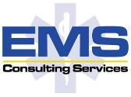
Market Sizing Memorandum
To: Stephen Parente, Ph.D.
From: Eric Malcolm Smith, JD – President and CEO, EMS Consulting Services
Date: March 8, 2013
Re: FQHC Expansion Plan

Introduction:
With the enactment of the Patient Protection and Affordable Care Act (ACA) on March 23, 2010, the face of American health care changed dramatically. By 2016, 32 million more Americans will be covered under some form of health insurance, generating millions of new clinic visits. A large portion of these new patients will be covered under Medicaid, as eligibility is expected rise to 133% of the Federal Poverty Level (“FPL”) for all individuals and families in 2014. Federally-Qualified Health Centers (“FQHCs”) in early opt-in Medicaid states like Minnesota (newly expanded coverage to single childless adults below 75% FPL) are already seeing gains in operating revenues from this expansion. And with further Medicaid expansion most likely rolling-out in 2014, Minnesota FQHCs will see even greater revenue gains. In Minnesota, Medicaid coverage is expected to rise by an additional 87000 beneficiaries with Governor Dayton making Minnesota’s full Medicaid expansion law on February 19, 2013.
FQHCs are primary care and preventative clinics that provide a variety of services including checkups, dental care, mental health services, family planning, and substance abuse services. They usually serve medically underserved areas and populations, migrants, homeless, and the poor. FQHCs are unique in that they receive free malpractice insurance through the federal Tort Claims Act, enjoy preferential cost-based Medicaid reimbursement, and are eligible for a variety of federal and state grants. As of 2010, in Minnesota there were 15 FQHCs. The revenue of a typical Minnesota FQHC breaks down like so: Medicaid 38.8%, Federal Grants 22.4%, State & Local Grants/ Contracts 10.5%, Foundation/Private Grants/ Contracts 6.9%, Private Insurance 6.4% Patient Self-Pay 5.0%, Medicare 4.3%, Other Public Insurance 2.5%, and Other Revenue 3.2%.
As evidenced through the aggregate statewide payer mix, FQHCs are highly Medicaid dependent, and have very few private and self-pay patients. As a result, a dramatic shift in FQHC revenue can be seen starting mid-2011, when Minnesota’s initial early Medicaid expansion took hold. As an example, let’s look at Cedar Riverside People’s Center (“Cedar Riverside”), an FQHC in the Twin Cities Metro:
FY2010 FY2011
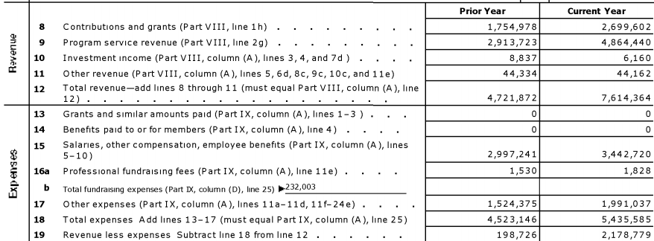
Evident in Cedar Riverside’s tax return is a dramatic increase in revenue in FY2011; overall revenue less expenses grew 996%. Most importantly, though, program service revenue grew 66.9%. This is most likely comprised of an increase in Medicaid-eligible patients, along with former GAMC/MNCare patients being assigned the more generous FQHC cost-based Medicaid rates. Cedar Riverside indicates that they saw a 19% increase in patient visits in 2011 over the previous year (15015 to 17868). Interestingly, salaries at Cedar Riverside only grew at 14.9%, indicating that staff were able to handle increases in patient demand well below the cost of seeing additional Medicaid patients. This labor efficiency is a common trait of FQHCs. Typically for every physician employed (Cedar Riverside has 3), there are between 6 and 7 non-physician care providers. Hence, when volume goes up, salaries don’t go up in equal proportion, as cheaper, non-physician employees are usually the staff who are hired first.
Because FQHCs enjoy very high Medicaid reimbursement and a relatively low fixed cost structure, they are very profitable. They are only going to become more profitable as Medicaid expands, as evidenced through Cedar Riverside’s revenue numbers during the initial phases of Medicaid expansion.
Recommendation:
Because an additional 87,000 Medicaid beneficiaries are expected to flow into Minnesota, a real opportunity exists for investors savvy to the real revenue gain possibilities afforded by the FQHC structure. Creating an FQHC from scratch, though, is hard. Application for FQHC status is highly prescriptive, with requirements for the FQHC organization to serve specific underserved populations and areas. For many investors, this is a frustrating and laborious process rife with uncertainty.
Becoming a satellite of an existing FQHC, though, is relatively easy. New acquisitions and constructions of clinics under the corporate umbrella of an existing FQHC do not require re-application for FQHC status; they can simply open and get preferential FQHC treatment. For this reason, the recommended course of action is to open or acquire a new FQHC clinic under the corporate umbrella of an existing FQHC.
The following is an analysis of a new Twin Cities FQHC clinic associated with an existing FQHC:
Cedar Riverside Patient-Visits | 17868
New FQHC Patient-Visits | 6000
Scaling factor (New/CR) | 0.335795836
New FQHC Revenue (1yr)
Contributions and grants | 453,257.6
Program service revenue | 1,633,458.7
Total revenue | $2,086,716.25
Salaries | 1,156,051.0
Other expenses | $334,290.97
Total expenses | $1,490,342.01
Revenue less expense | $596,374.24
Assumptions:
- The new FQHC will have a relatively modest 6000 patient-visits. This is conservative, as there will be 87,000 new Medicaid patients, many of whom will be in the Twin Cities metro.
- Contributions and grants are scaled to 6000 patient-visit level, then reduced by half, as parent FQHC will most likely garner grants funds otherwise apportioned to satellite. Becoming part of an existing FQHC will most likely lower the new satellite’s ability to apply for grants independently, as the parent FQHC will most likely have already taken advantage of the limited grant dollars available. But, if the satellite clinic can establish differentiation from the parent FQHC, the potential for additional grant monies still exists.
- Program service revenue are Cedar Riverside program revenue times scaling factor. This is also relatively conservative, as payer mix is expected to improve with further Medicaid expansion.
- Salaries are Cedar Riverside salaries times scaling factor. Because there are only 6000 patient-visits, only one physician will need to be employed.
- Other expenses are Cedar other expenses times scaling factor, then reduced by half, as the parent FQHC will most likely take care of a large portion of administrative, EMR, and maintenance expenses.
Conclusions:
Even if investors assume a $1M purchase of a new facility, $500,000 in initial equipment and supply purchase (estimated), and a constant patient-visit level, the new FQHC venture will yield a positive net present value over the course of 5 years. At a 10% discount rate, the 5-year NPV (with no year 5 terminal value) for this new FQHC is $760726.66, with breakeven being achieved in year 4. This initial cash outlay could be reduced, too, through acquisition of an existing non-FQHC clinic, rather than construction of a new clinic. Many existing clinics are willing to entertain this option, as non-FQHC clinics don’t enjoy the same preferential cost-based Medicaid reimbursement.

EMS Consulting recommends getting into the FQHC space quickly. For further advice, please don’t hesitate to contact us.

CBO’s Analysis of the Major Health Care Legislation Enacted in March 2010. Congressional Budget Office. March 30, 2011. http://www.cbo.gov/sites/default/files/cbofiles/ftpdocs/121xx/doc12119/03-30-healthcarelegislation.pdf
Minnesota's Early Medicaid Adult Expansion. SHADAC, April 14, 2011. http://www.shadac.org/files/shadac/publications/GibsonSlides_EarlyMedicaidExpansion.pdf
2011 Cedar Riverside Peoples Center IRS form 990 (In attached appendix)
(35000 new enrollees, and 52000 rolled-over form MNcare) Dayton gets Minnesota bill expanding Medicaid rolls. WDAY-6, February 14, 2013. http://www.wday.com/event/article/id/75336/group/homepage/
What are Federally qualified health centers (FQHCs)?, HRSA. http://www.hrsa.gov/healthit/toolbox/RuralHealthITtoolbox/Introduction/qualified.html
Minnesota: Federally Qualified Health Centers. Kaiser Family Foundation. http://www.statehealthfacts.org/profileind.jsp?cat=8&sub=99&rgn=25
Dayton’s Medicaid Expansion http://www.mn2020hindsight.org/view/daytons-medicaid-expansion
Cedar Riverside Peoples’ Center, Who we see http://www.peoples-center.org/about-us/who-we-see/
1 Physician per 6000 patient visits. http://www.raconline.org/topics/clinics/fqhcfaq.php#staffing
CMS FQHC Guidelines. http://www.cms.gov/Center/Provider-Type/Federally-Qualified-Health-Centers-FQHC-Center.html?redirect=/center/fqhc.asp
Construction Cost Estimates for Medical Office (1 Story) in National, US http://www.reedconstructiondata.com/rsmeans/models/medical-office/

