memorandum
to: Professor Steve Parente
from: Tony Capecchi
Course: MILI 6990 Health care marketplace
subject: geriatric nurse practitioner COnsultation: market Sizing Memo
date: 2/9/2015

Of all the emerging health care trends in the U.S., none looms larger on the horizon than the unprecedented––and unstoppable––increase in the elderly population. Specifically in Minnesota, the senior population in the Twin Cities area will double between 2010 and 2030, and will grow from 307,000 seniors in 2010 to 770,000 seniors in 2040.
This surge means that by 2040, one in every five people residing in the Twin Cities will be a senior citizen. The explosive growth of this demographic, coupled with the intricate complexity of senior care, is the driving force behind my business opportunity: starting a private, Twin Cities-based consulting company run by a Geriatrics Nurse Practitioner advising seniors and their families on senior care options and available resources.
The Venture
Capecchi Senior Care Consulting will be a private business based on consultative work done by a Geriatric Nurse Practitioner operating a private firm to help patients facing difficult decisions with senior and end-of-life care.

The nurse practitioner, in collaboration with an RN and a collaborating physician both working part-time hours, will assess patients’ needs to address questions such as: Do they need skilled nursing, custodial care, companionship, physical therapy, social services or financial assistance? Do they know what local and government resources are available? Do they need long-term care or assisted living? Can they afford 24-7 assisted support?

Target Audience
The target audience is a) wealthy senior citizens who can privately pay for consultations, and b) families with means and a loved one facing senior and end-of-life care. A key sub-section of this audience will be successful, adult children who no longer live in the same state as their senior citizen parent.
Industry Engagement & Partnering Agents
To be successful, Capecchi Senior Care Consulting will require a collaborating physician for oversight and a part-time RN for assisting with patient visits. The firm will also require the engagement of insurance companies and good relationships with local pharmacies (to advise with polypharmacy and the unique metabolism of drugs among seniors). Two other critical relationships will be open contacts with local social workers as well as relationships with providers such as hospitals, assisted living, hospice, etc.

Financials
Capecchi Senior Care Consulting can generate positive ROI within 5 years. I am looking to launch this business in partnership with my wife (a Geriatric Nurse Practitioner) in 2020, at which time the projected population of seniors age 65+ in the Twin Cities in 461,000. If the firm attracted .00005% of that population as clients, it would result in 23 patients, which exceeds our target number of patients per year as our objective is for the Consulting firm to be only a part-time operation for my wife and me. Below are calculations showing best- and worst-case scenarios, with two different billing options.

Our goal is to bill $350/hour, which will place us at a premium versus Allina’s Home Care, Hospice and Palliative Care rate sheet, shown in the appendix below. Salary expenses for collaborative physician and RN are based on current market rates, with the plan of allotting half of the billable hours to the RN, while having my wife, the Nurse Practitioner, attend to the other half of the billable hours. Hence our Salary Expenses are based on the RN ($45/hr x 50% of billable hours) + the physician (negotiated retainer).

For the best-case scenario I am using the assumption we will attract .0001 percent of Twin Cities senior citizens as customers; for the worst-case the assumption is .00005%

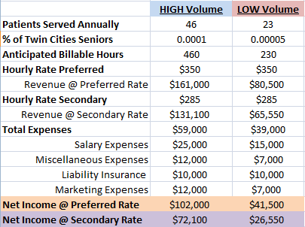

In review, this analysis shows this would be a viable business opportunity, with an anticipated profit ranging from $72,100 - $102,000 if we maintain our preferred billing rate at the higher volume projected, and a profit ranging from $41,500 - $26,550 if we charge the secondary billing rate. This range would be acceptable for Capecchi Senior Care Consulting as the objective is for it to be a part-time enterprise to supplement my current income at 3M.
Appendix
Exhibit 1
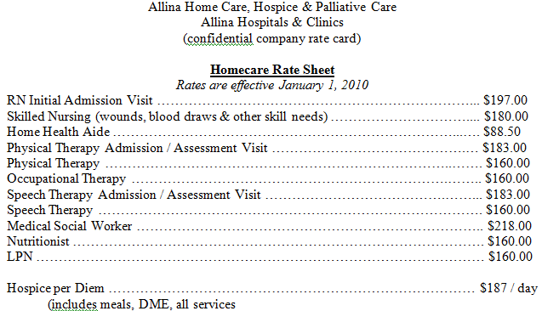

Exhibit 2: Demographics of MN, Twin Cities Area
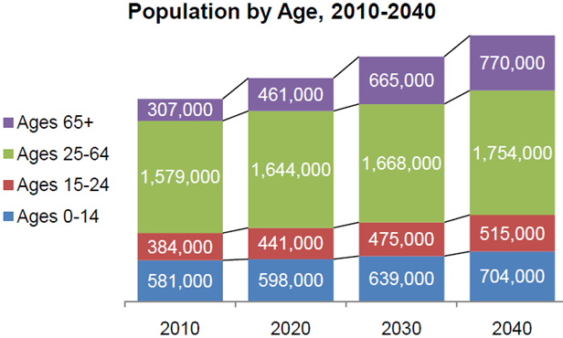

Exhibit 3: U.S. Projected Population
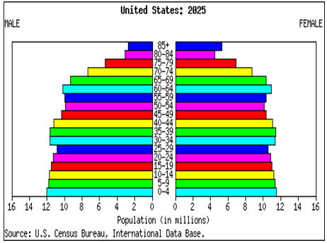

Minnesota Department of Administration, Data Set Feb 21, 2013, per MN State Demographic Center
Metropolitan Council, Metro Stats Forecasts April 2012

